MINI PROJECT REPORT

24MNC 120 DESIGN AND ENGINEERING

Submitted

By

1. KEVIN KANNIYAKONIL BIJU, AJC24CS130
2. DON KALAVANAL MICHAEL, AJC24CS089
3. MANAS GOPINATH, AJC24CS137
4. EDWIN VIJU, AJC24CS130

In partial fulfillment for the award of the degree

of

Bachelor of Technology

IN

COMPUTER SCIENCE AND ENGINEERING

DEPARTMENT OF COMPUTER SCIENCE AND ENGINEERING
AMAL JYOTHI COLLEGE OF ENGINEERING (AUTONOMOUS),
kanjirapally 686 518

JANUARY 2025
AMAL JYOTHI COLLEGE OF ENGINEERING (AUTONOMOUS), kanjirapally
DEPARTMENT OF COMPUTER SCIENCE AND ENGINEERING
BONA FIDE CERTIFICATE

This is to certify that the Mini Project Report entitled “PROXY SMART” submitted by DON KALAVANAL MICHAEL (AJC24CS089), EDWIN VIJU (AJC2024CS249), MANAS GOPINATH (AJC24CS137) and KEVIN KANNIYAKONIL BIJU (AJC24CS130) in partial fulfillment of the requirement for the award of the Bachelor of Technology in Computer Science and Engineering is a bona fide record of the work carried out at AMAL JYOTHI COLLEGE OF ENGINEERING (AUTONOMOUS), under our guidance and supervision.

INTERNAL EXAMINER  Mr. ABI VARGHESE  DESIGNATION  MECHANICAL ENGINEERING | HEAD OF THE DEPARTMENT  Dr. JUBY MATHEW  DESIGNATION  COMPUTER SCIENCE

TABLE OF CONTENTS

CHAPTER NO. | TITLE  ACKNOWLEDGEMENTS  ABSTRACT  LIST OF TABLES |  | PAGE NO.  4  5  6
 | LIST OF FIGURES |  | 6

Chapter 1: Introduction 8-9
1.1 Personal Security and Valuables Safety
1.2 Objectives of the Research
Chapter 2: Literature Review 10-13
2.1 Problem Statement
2.2 Gap Identification
2.3 Design Objectives
Chapter 3: UI Design Overview 13-19
3.1 Login Page
3.2 Main Page
3.3 Range Page
3.4 Warning Page
Chapter 4: Prototype Overview 20-25
4.1 Development Steps
4.2 Testing and Debugging
4.3 Enclosure Design and Assembly
Chapter 5: Conclusion 26-27
5.1 Summary of Results
5.2 Future Work
References

ACKNOWLEDGMENT

.
We extend our sincere gratitude to my beloved Design and Engineering teacher Mr. Abi Varghese Sir for the invaluable and powerful motivation.
We also thank all our friends and family for all the support and motivation given during the preparation of this project.

ABSTRACT
This concept proposes an innovative electronic device paired with a mobile app, designed to enhance the security of personal belongings such as travel bags and purses. The device, which can be easily attached to bags or valuables, is programmed to trigger an alarm when the proximity between the device and the user’s smartphone exceeds a predetermined distance, set within the app. Distances can be customized in increments (e.g., 2m, 5m, 10m, 20m, 30m, 40m, and 50m), allowing the user to define the ideal range of proximity for optimal security. When this range is breached, both the device and the phone emit an alarm, alerting the user to potential theft or unauthorized movement of their belongings. To stop the alarm, the user must deactivate it through the app, adding an extra layer of control and security. Additionally, both the device and its alarm function can be toggled on or off via the app or directly on the device itself. This system is ideal for travelers, commuters, or anyone looking to safeguard their possessions, providing peace of mind and helping prevent theft or loss in crowded or public spaces.

LIST OF FIGURES:

Figure No | Figure Title | Page No
Figure 1.1  Figure 1.2  Figure 1.3  Figure 1.4  Figure 2.1  Figure 2.2 | Login Page  Main Page  Range Page  Warning Page  Protype Image 1  Prototype Image 2 | 14  15  17  18  21  23

LIST OF TABLES

Table No | Table Title | Page No
Table 1  Table 2 | Key Elements of App  Development Steps Of  Working Prototype | 19  21

Content

Chapter 1 - Introduction

Chapter 2 - Literature review

Chapter 3 - UI Design Overview

Chapter 4 – Protype Overview

Chapter 5 - Conclusion

Chapter 1
Introduction

In today’s world, personal security and the safety of valuables have become significant concerns, particularly in public spaces like airports, shopping centres, and crowded tourist attractions. The rise in pickpocketing, bag snatching, and opportunistic thefts makes it increasingly difficult for people to safeguard their possessions, especially when they are distracted or in unfamiliar environments. Traditional security measures, such as locks, chains, or tags, offer limited protection and often fail to provide immediate alerts or real-time responses when valuables are compromised.
The motivation to develop an electronic device and an app focused on preventing theft stems from the need for a more intuitive, user-friendly, and effective solution to protect personal belongings in an increasingly mobile and fast-paced world. Travel bags, purses, backpacks, and other personal items are often targets for theft, but current security devices lack the ability to notify the user in real-time or prevent the loss before it occurs.
This system combines proximity sensors with customizable distance settings, which are controlled via an intuitive app. By allowing users to set a specific distance range (2m, 5m, 10m, 20m, 30m, 40m, or 50m), the device emits an alarm if the set proximity threshold is breached by either the phone or the device. This gives users a clear, immediate signal that their belongings are at risk. Both the device and phone will ring, ensuring the user is alerted from multiple sources. The device’s alarm can only be turned off using the app, providing an additional layer of control. This system not only alerts users but also helps deter potential thieves by drawing attention to the situation. This innovation represents a proactive step toward personal security, offering users peace of mind in both familiar and unfamiliar environments.

Chapter 2
Literature review

2.1 Problem Statement
Personal security and the protection of valuables remain significant concerns, especially in crowded environments like airports, public transportation, and tourist destinations. Opportunistic theft, such as pickpocketing or bag-snatching, is on the rise, and traditional security measures like locks or tags often fail to provide real-time alerts or proactive protection. The motivation for creating this electronic device and app is to offer a more effective solution for safeguarding personal belongings.
This system uses proximity sensors to set customizable distance limits through the app. When the set distance is breached, both the device and the phone emit an alarm, alerting the user of potential theft. The alarm can only be deactivated via the app, ensuring the user remains in control. This device is perfect for travel bags, purses, and other valuables, providing immediate alerts to prevent theft and offering peace of mind to users in public spaces.

2.2 Gap Identification
The gap in current theft prevention solutions lies in the lack of real-time, customizable alerts for users to monitor their valuables. Traditional security devices, such as locks and basic alarms, do not offer proactive protection or notify users when their personal belongings are at risk in real-time. Additionally, many existing solutions are passive, relying on physical security measures that fail to provide immediate responses or require manual intervention.
This electronic device and app address the gap by offering dynamic, adjustable proximity settings that trigger simultaneous alarms on both the device and phone when a breach occurs. This ensures instant alerts, giving the user more control over their belongings. Furthermore, the alarm can only be turned off through the app, eliminating accidental deactivation. The integration of proximity sensors, real-time alerts, and app control fills the need for an efficient, user-friendly, and proactive theft prevention system, particularly for travel bags and purses.

2.3 Design Objective
The design objective of this electronic device and app is to provide a proactive, customizable security solution for protecting personal belongings from theft in public spaces. The device, paired with a mobile app, aims to alert users when their valuables, such as travel bags or purses, are moved beyond a predefined proximity distance (2m, 5m, 10m, etc.), which is set within the app. Upon breach, both the device and the user's phone emit an alarm, notifying the user in real-time of potential theft. The alarm can only be deactivated through the app, ensuring full control over the system. Additionally, the device can be turned on or off via both the app and the device itself, providing flexibility and ease of use. The primary goal is to enhance personal security by offering immediate alerts, preventing theft, and ensuring peace of mind, especially in crowded environments where individuals are most vulnerable to theft.

2.4 Design Constrain
The design constraints for this electronic device and app to prevent potential theft include:
- Battery Life: The device must be designed with energy efficiency in mind, ensuring the battery lasts for extended periods without frequent recharging, especially when in constant use for security purposes. This may limit the types of sensors and communication technologies used.
- Range and Accuracy: The proximity range (2m, 5m, 10m, etc.) must be accurate and reliable across various environments. The device needs to work effectively in different conditions, including crowded public spaces, while minimizing false alarms due to environmental factors like interference from other wireless devices.
- Durability: The device should be compact, lightweight, and durable enough to withstand everyday wear and tear. It needs to be water-resistant or resistant to environmental elements to function well in different conditions (rain, dust, etc.), especially for travel-related use.
- User Interface: The app must be intuitive, user-friendly, and accessible to a wide range of users. It should be easy to configure the proximity settings, activate/deactivate the device, and respond to alarms quickly without causing confusion or frustration.
- Connectivity: The device and app must maintain a stable connection, ideally using Bluetooth or similar technology, but without sacrificing security or requiring excessive power consumption.
- Security: The communication between the app and the device must be secure to prevent unauthorized access, ensuring the integrity of alarm functions and user settings.
- Cost: The cost of manufacturing the device and app should be reasonable to make the product accessible to a broad user base, without compromising on essential features or quality.
- Compatibility: The app must be compatible with a wide range of smartphones and operating systems (iOS, Android) to ensure maximum usability for potential users.

Chapter 3
UI Design Overview
1.1 Login Page
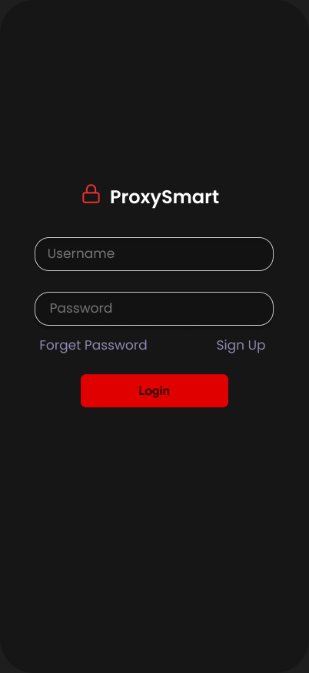

The login page of our tracking device app provides a clean and straightforward interface for secure access. Users can log in effortlessly using their registered email ID and password. The page emphasizes simplicity and usability, ensuring a seamless experience while maintaining robust security measures.

1.2 Main Page
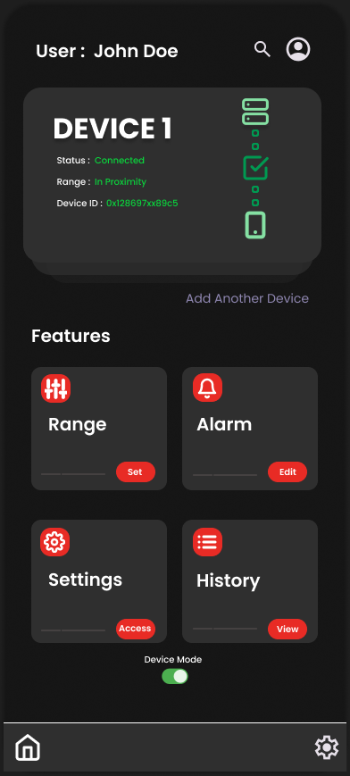

Key Features:

- Range

- Configure the proximity range for your tracker.
- The device alerts with a beep when it moves out of the set range, ensuring you never lose track.

- Alarm

- Customize the notification tone and volume.
- Choose from pre-set tones or add a custom sound for device alerts.

- Settings
- Access and modify the tracking device settings.
- Includes options for connectivity, device pairing, and app preferences.

- History

- View a detailed log of instances when the device left the defined range.
- Helps track patterns and enhance usability.

With these features organized on the home page, users can effortlessly manage their tracking needs and ensure their devices stay within reach.

1.3 Range Page
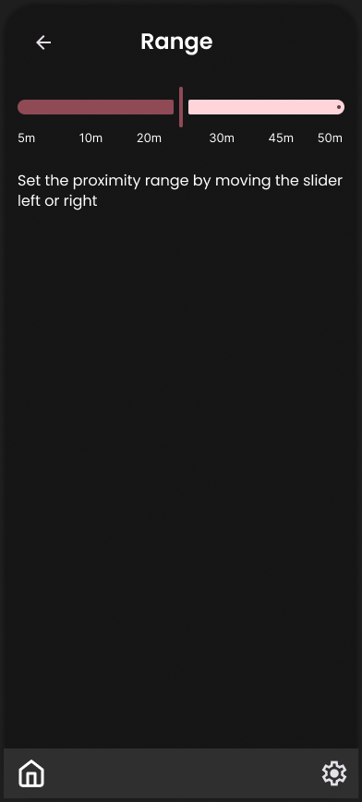

The Range Page allows users to configure the proximity distance for their tracking device using an intuitive slider interface. This page is designed to provide precise control over the range settings, ensuring the device functions optimally within the user’s preferences.

Key Features:
- Slider for Range Adjustment
- A smooth and interactive slider to set the desired proximity range.
- Displays the selected distance in clear numerical values (e.g., meters or feet).
- Real-Time Feedback

As the slider is moved, the app provides real-time updates on the range being set, ensuring accuracy.
Includes minimum and maximum range limits to guide users.

1.4 Warning Page
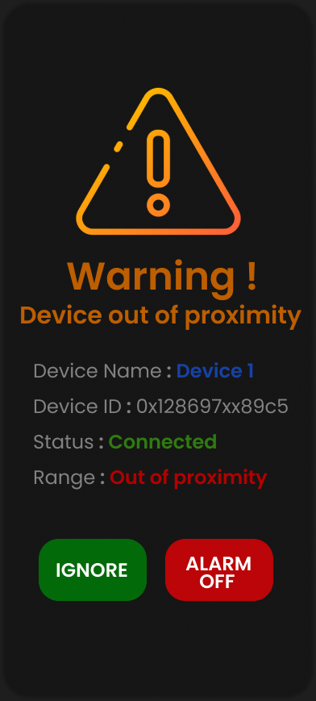

The Warning Page is an alert screen that appears when the tracking device moves out of the defined proximity range. It provides critical information at a glance to help users quickly assess the situation and take appropriate action.

Key Elements of App:
- Device Name
- Clearly displays the name of the device for easy identification, especially when managing multiple devices.
- Device ID
- Shows the unique identifier of the device, ensuring precise tracking and differentiation between multiple connected devices.
- Device Status
- Indicates whether the device is currently Connected or Disconnected, giving users clarity on the connection state.
- Range Status
- Alerts if the device is Out of Proximity or still within the specified range, allowing users to understand the situation instantly.

Table 1

Chapter 4
Prototype Overview
FIGURE 2.1
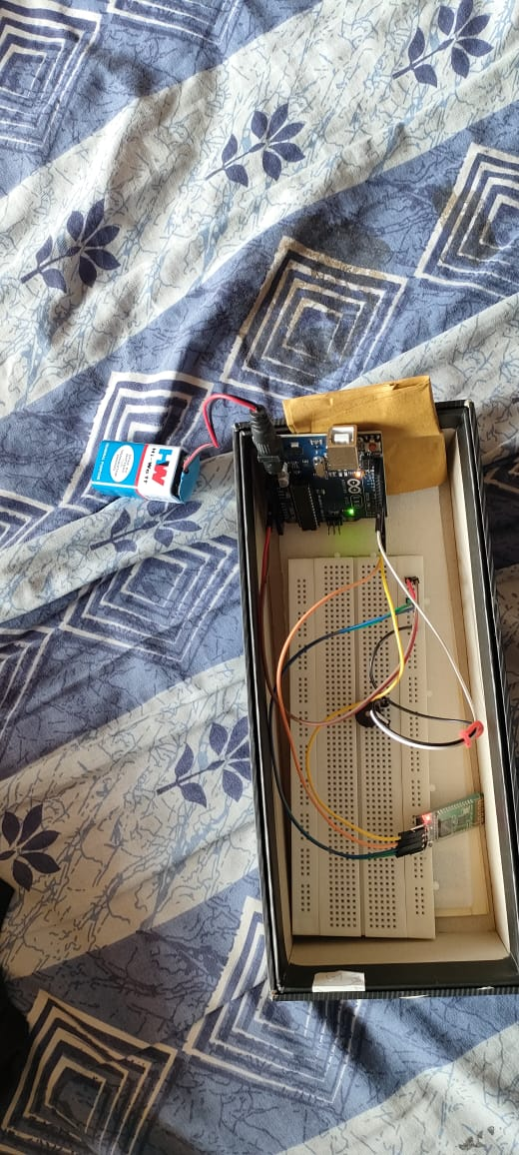

Table-2
Development Steps:
Step 1: Hardware Component Selection and Procurement
1. Select and procure the necessary hardware components, including:
1. Arduino Uno
2. HC-05 Bluetooth Module
3. 5W Piezo Buzzer
4. 9V Battery
5. Breadboard
6. Jumper Wires
2. Verify the compatibility and specifications of each component.
Step 2: Circuit Design and Prototyping
1. Design the circuit diagram using a software tool or manually.
2. Assemble the circuit on the breadboard using jumper wires.
3. Connect the Arduino Uno, HC-05 Bluetooth Module, Piezo Buzzer, and battery.
4. Verify the circuit connections and ensure proper power supply.
FIGURE-2.2
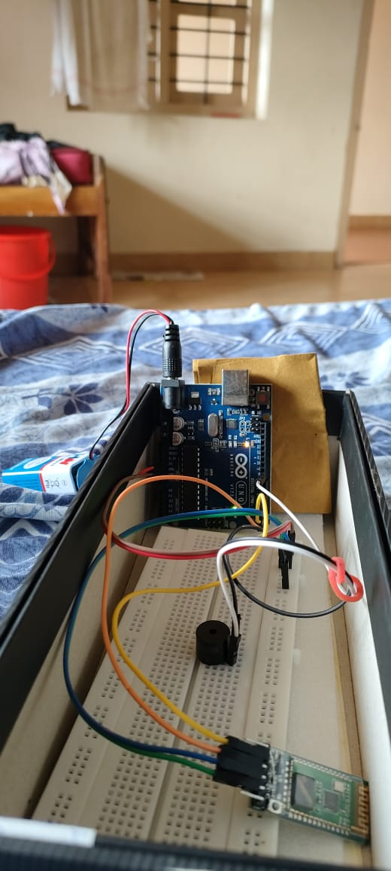

Step 3: Arduino Programming
1. Write and upload the Arduino code to the Arduino Uno board.
2. Program the Arduino to:
1. Read RSSI values from the HC-05 Bluetooth Module.
2. Estimate distance based on RSSI values.
3. Trigger the Piezo Buzzer when the distance exceeds the set threshold.
3. Test and debug the Arduino code.
Step 4: Bluetooth Module Configuration
1. Configure the HC-05 Bluetooth Module using AT commands.
2. Set the Bluetooth module to work in slave mode.
3. Pair the Bluetooth module with a smartphone or tablet.
Step 5: Distance Threshold Setting and Testing
1. Set the distance threshold using the Arduino code or a mobile app.
2. Test the device by moving it away from the paired smartphone or tablet.
3. Verify that the Piezo Buzzer triggers when the distance exceeds the set threshold.
Step 6: Mobile App Development (Optional)
1. Develop a mobile app to communicate with the HC-05 Bluetooth Module.
2. Design the app to:
1. Set the distance threshold.
2. Receive alerts when the distance exceeds the threshold.
3. Display the RSSI values and estimated distance.
3. Test and debug the mobile app.
Step 7: Testing and Debugging
1. Test the entire system, including the Arduino code, Bluetooth module, and mobile app (if developed).
2. Debug any issues that arise during testing.
3. Refine the system to ensure accurate distance measurement and reliable alerts.
Step 8: Enclosure Design and Assembly (Optional)
1. Design an enclosure for the prototype using a 3D printing or laser cutting.
2. Assemble the enclosure and integrate the circuit and components.
3. Ensure proper ventilation and accessibility for maintenance.
Step 9: Final Testing and Deployment
1. Conduct final testing of the prototype to ensure it meets the requirements.
2. Deploy the prototype in a real-world scenario.
3. Monitor the performance and gather feedback for future improvements.

Chapter 5
Conclusion

In conclusion, the proposed electronic device and app offer an innovative and effective solution to the growing problem of theft in public spaces, especially for travellers and individuals in crowded environments. By combining proximity sensors with real-time notifications, the system provides users with a proactive method to safeguard their personal belongings, such as travel bags, purses, and backpacks. The app's ability to set customizable proximity thresholds ensures flexibility, allowing users to adjust the alert range according to their environment, whether it be a busy airport or a crowded market. The device's alarm, triggered when the proximity limit is breached, and the simultaneous alert on the user’s phone, provide an immediate response, enabling quick intervention.
The integration of the app with the device also offers full control, allowing users to turn the system on or off easily and ensuring that the alarm can only be deactivated through the app. This layer of control prevents accidental deactivation and ensures that the system remains active as long as needed. The device's portability, ease of use, and seamless connectivity with smartphones enhance its practicality for everyday use.
Despite challenges related to battery life, range accuracy, and ensuring robust connectivity, the solution addresses significant gaps in current security measures, providing a reliable and user-friendly way to prevent theft. Ultimately, this system empowers users to take control of their personal security, offering peace of mind and protection for their belongings in an increasingly mobile and unpredictable world.

REFERENCES

- Arduino (2025) 'Arduino Uno technical documentation', Available at: https://www.arduino.cc (Accessed: 8 January 2025).
(Referenced for hardware component selection and programming details.)
- Bluetooth SIG (2025) 'Bluetooth Low Energy: Technology Overview', Available at: https://www.bluetooth.com/what-is-bluetooth-technology/bluetooth-low-energy (Accessed: 8 January 2025).
(Used for BLE protocols and stable communication techniques.)
- Piezo Electric Technology (2025) 'Applications of Piezoelectric buzzers', Available at: https://www.piezotechnologies.com (Accessed: 8 January 2025).
(Referenced for the usage of piezo buzzers in alert mechanisms.)
- OpenAI (2025) 'ChatGPT: An AI-powered conversational model for generating text', Available at: https://www.openai.com/chatgpt (Accessed: 8 January 2025).
(Used for drafting content and generating ideas for project documentation.)
- Figma (2025) 'Figma: Collaborative interface design tool', Available at: https://www.figma.com (Accessed: 8 January 2025).
(Referenced for UI/UX app design.)
- Android Developers (2025) 'Developing apps for Bluetooth communication', Available at: https://developer.android.com (Accessed: 8 January 2025).
(Used for developing the mobile app and ensuring smooth connectivity.)
- ISO (2010) 'ISO 9241-210: Ergonomics of human-system interaction', Available at: https://www.iso.org (Accessed: 8 January 2025).
(Guided the design constraints for user-centric and ergonomic interfaces.)
- Maker Projects (2025) 'Prototyping enclosures using 3D printing', Available at: https://www.makerprojects.com (Accessed: 8 January 2025).
(Referenced for the enclosure design and assembly process.)
- Mohan, R. (2021) 'IoT-based theft prevention systems: A comparative study', International Journal of Engineering Research, Vol. 10, No. 3, pp. 145-152.
(Cited for identifying gaps in existing theft prevention systems.)

